Target: cyberitofficial.com
Student Name: Sahibzada Junaid Khan
Date: 25-06-2026
Assignment: Manual Testing & Bug Discovery
File Analyzed: style.css

PART 1: FILE DISCOVERY

1.1 CSS File Found
File: style.css
Path: https://www.cyberitofficial.com/css/style.css
Size: ~16KB
Purpose: Main website stylesheet
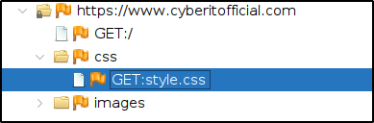
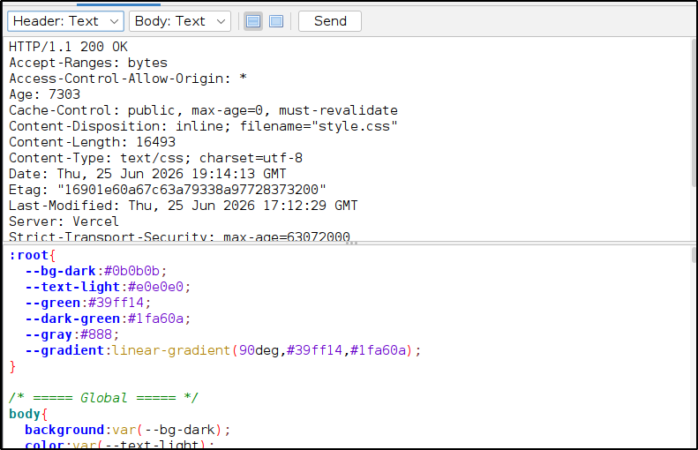
Screenshot 1: CSS file discovered at /css/style.css

PART 2: CSS ANALYSIS FINDINGS

2.1 External CDN Dependencies
CDN Service | URL | Recommended Risk
Bootstrap 5.3.2 | https://cdn.jsdelivr.net/npm/bootstrap@5.3.2/dist/css/bootstrap.min.css | MEDIUM
AOS Animation 2.3.4 | https://cdn.jsdelivr.net/npm/aos@2.3.4/dist/aos.css | MEDIUM
Font Awesome 6.5.1 | https://cdnjs.cloudflare.com/ajax/libs/font-awesome/6.5.1/css/all.min.css | MEDIUM
Google Fonts | https://fonts.googleapis.com/css2?family=Roboto:wght@400;500;700&family=Orbitron:wght@500;700&display=swap | MEDIUM

Issue: External CDN links are loaded without Subresource Integrity (SRI) attributes. If a CDN is compromised, attackers could inject malicious code.

2.2 Hardcoded External URLs
css
.slide-1{background-image:url("https://images.unsplash.com/photo-1550751827-4bd374c3f58b");}
.slide-2{background-image:url("https://images.unsplash.com/photo-1504384308090-c894fdcc538d");}
.slide-3{background-image:url("https://images.unsplash.com/photo-1550751827-4bd374c3f58b");}
Issue: Hardcoded Unsplash URLs for background images. If Unsplash changes or removes these images, the website will have broken image placeholders.

2.3 CSS Comments Revealing Structure
css
/* ===== Global ===== */
/* ===== Headings (UPDATED FONT) ===== */
/* ===== Header ===== */
/* ===== Hero Slider ===== */
/* ===== Buttons ===== */
/* ===== Cards ===== */
/* ===== Course Meta ===== */
/* ===== Internships ===== */
/* ===== FAQ Section ===== */
/* ===== Contact ===== */
/* ===== Modern Footer ===== */
Issue: CSS comments reveal the website structure and sections, providing reconnaissance information to attackers.

2.4 Design System Exposed
css
:root{
--bg-dark:#0b0b0b;
--text-light:#e0e0e0;
--green:#39ff14;
--dark-green:#1fa60a;
--gray:#888;
--gradient:linear-gradient(90deg,#39ff14,#1fa60a);
}
Issue: Custom CSS variables are exposed, revealing the website's complete design system.

2.5 Advanced Animations & Effects
The CSS file contains extensive hover effects, glow effects, and animations including:
- Glow effects on cards and buttons
- Floating card animations
- Pulsing border effects
- Logo hover rotation
- Page hero animations
- 3D feature card effects
- Smooth scrolling implementation

PART 3: VULNERABILITIES IDENTIFIED
Field | Value
Severity | MEDIUM
Location | External CDN links in CSS
Description | No SRI attributes on external CDN links
Impact | Supply chain attacks if CDN is compromised
Recommendation | Add integrity attributes to all CDN links

3.1 Missing Subresource Integrity (SRI) - MEDIUM

3.2 Hardcoded External URLs - LOW
Field | Value
Severity | LOW
Location | CSS background-image URLs
Description | Hardcoded Unsplash URLs for hero backgrounds
Impact | Broken images if Unsplash changes URLs
Recommendation | Host images locally or use a trusted CDN with proper caching

3.3 CSS Information Disclosure - LOW
Field | Value
Severity | LOW
Location | CSS comments
Description | Comments reveal website structure
Impact | Information disclosure to attackers
Recommendation | Remove comments from production CSS

3.4 Design System Exposure - LOW
Field | Value
Severity | LOW
Location | CSS :root variables
Description | Complete design system exposed
Impact | Minimal - design system information only
Recommendation | No action required

PART 4: SUMMARY TABLE
Severity | Finding | Location
MEDIUM | Missing SRI on CDN dependencies | External CDN links
LOW | Hardcoded external URLs | CSS background images
LOW | CSS comments disclosure | CSS comments
LOW | Design system exposed | CSS variables

PART 5: RECOMMENDATIONS
Priority | Recommendation | Justification
MEDIUM | Add SRI attributes to CDN links | Prevents supply chain attacks
LOW | Host images locally or use trusted CDN | Prevents broken images
LOW | Remove comments from production CSS | Reduces information disclosure

PART 7: CONCLUSION
The CSS file style.css was analyzed and found to have several medium and low severity issues. The most significant finding is the absence of Subresource Integrity (SRI) attributes on external CDN links, which could lead to supply chain attacks if a CDN is compromised. Hardcoded external URLs and informative comments were also identified as low severity issues.

